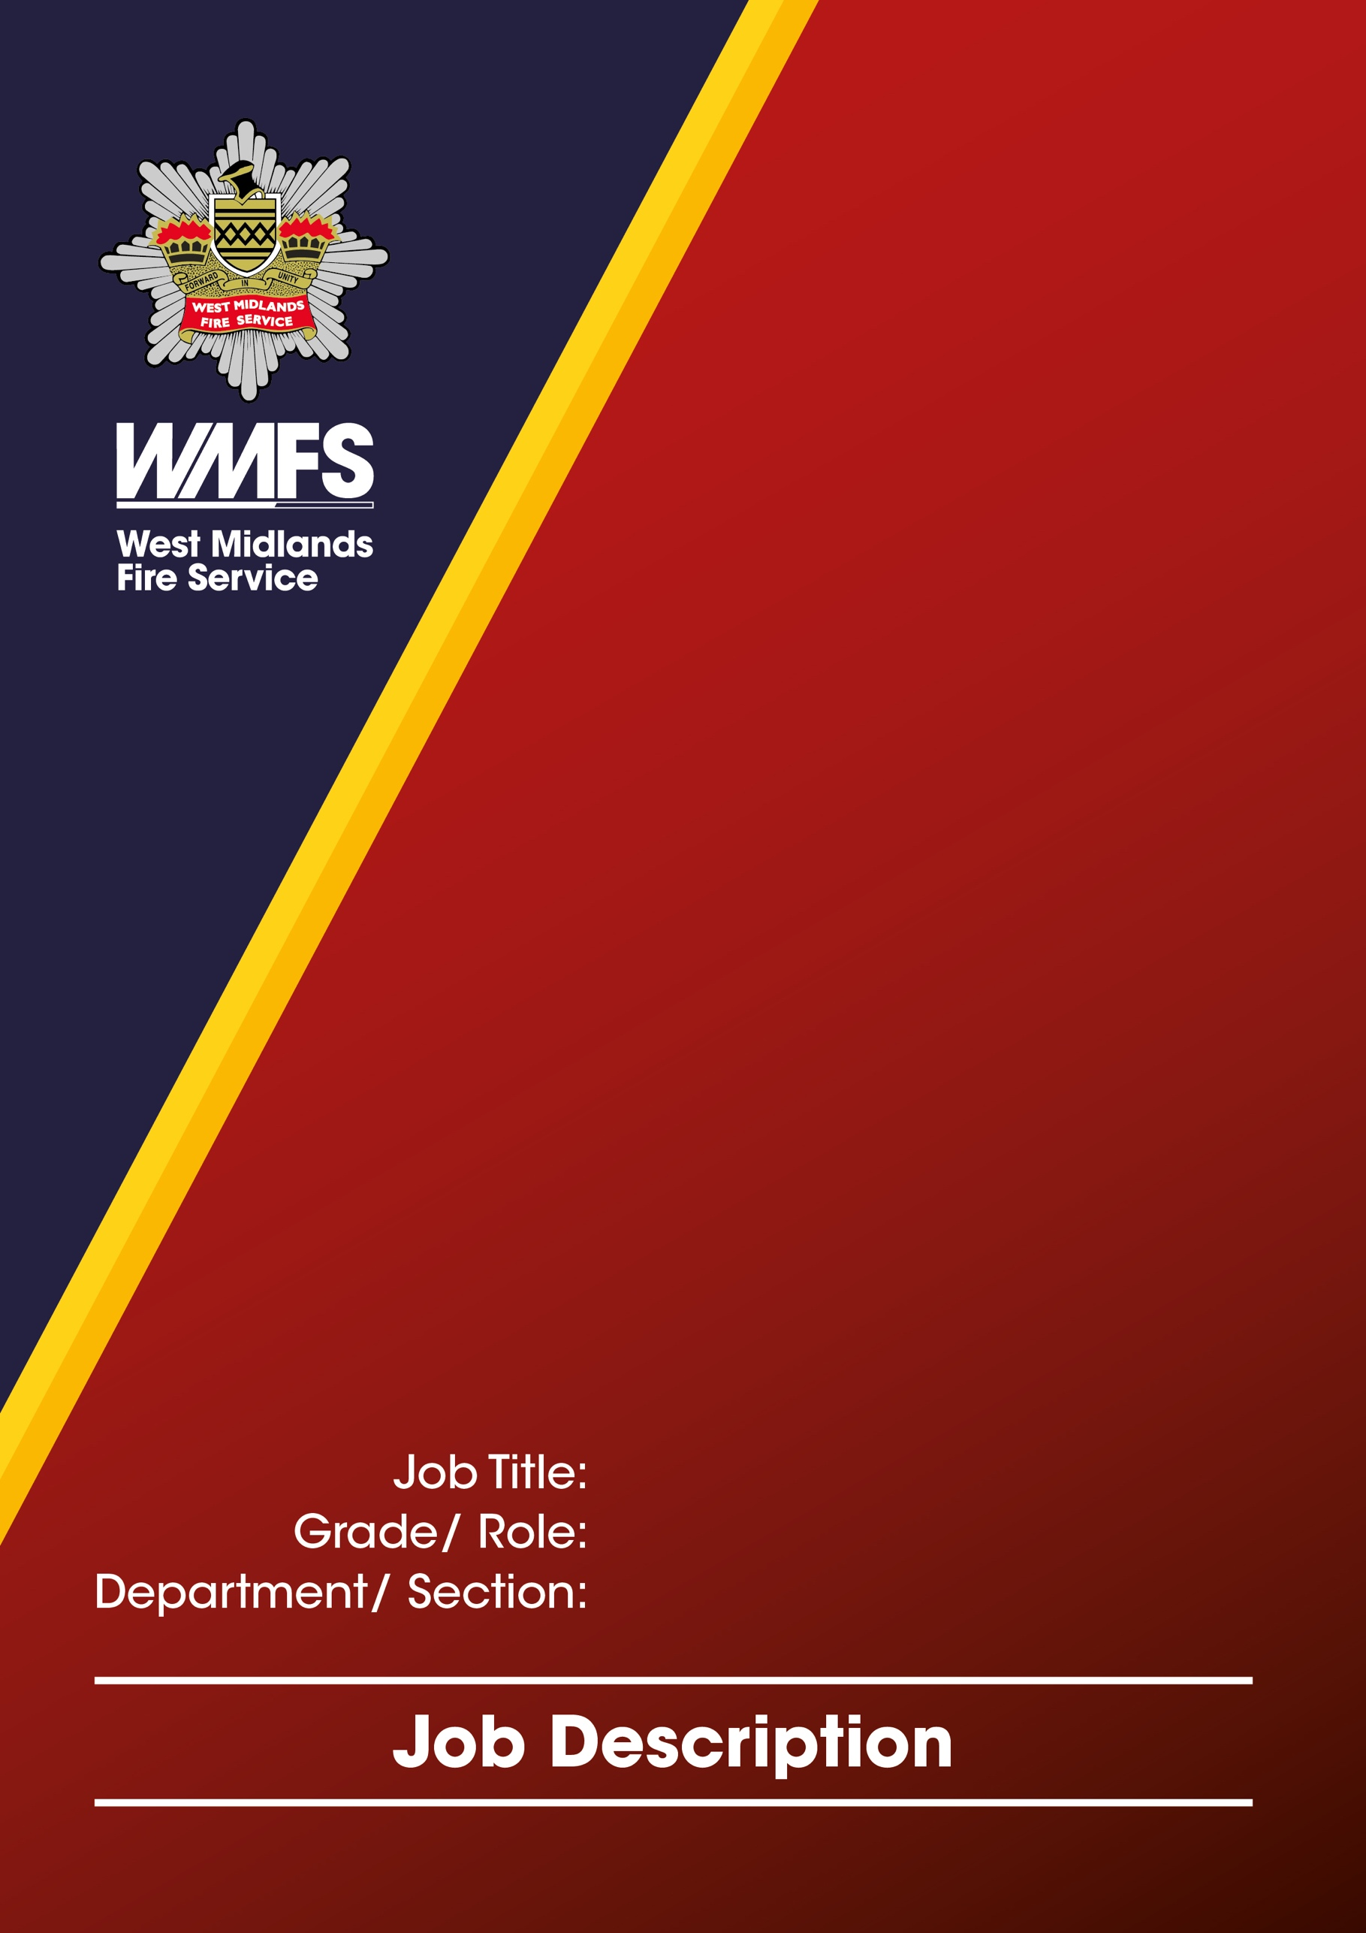
Principal Workshop Technician
Technical 1B
Transport Engineering Workshops (TEW) / Corporate Services
JOB DESCRIPTION

Job Title: | Principal Workshop Technician
Grade / Role: | Technical 1B
Reports to: | Workshop Manager
Section: | Corporate Service
Department: | Transport Engineering Workshops (TEW0

Job Summary

Under the direction of TEW Workshop Manager, responsible for overseeing the day-to-day operations of the vehicle and equipment repair and maintenance workshop
Combining hands-on technical expertise with supervisory responsibilities to ensure all vehicles are serviced, repaired, and maintained to the highest standards. Managing a team of technicians, coordinating workflow, diagnosing mechanical issues, ensuring safety compliance, and maintaining accurate service records.

Responsibilities and Duties

Supervise employees in the Workshop including maintaining good timekeeping and discipline.

Ensure all service and repair schedules are adhered to too, producing KPI’s and relevant data at ISO meetings, providing improvement plans and alternative methods of work.

Prioritise the use of labour as required, to mitigate the use of spare appliances and unnecessary visits to TEW by fire crews.

Maintain the use of spare appliance as required to support maximum fire cover.

To advise workshop Technicians on repairs, servicing, and other technical problems, ensuring all expected time frames are met and provide further training or support via improvement plans for technicians who do not perform to expected levels.

To ensure all aspects of the Health and Safety at Work Act are implemented and ensure safe working methods are adopted, formulate and implement risk assessments and keep existing risk assessments relevant and up to date.

To allocate and progress workflow and check quality and quantity of work.

Compose and update service sheets, progress reports and inspection requirements to meet the current and changing fleet requirements by implementing legislative and business requirements.

Carry out presentations to employees and other departmental workers where required to demonstrate complex or new information relevant to your role and knowledge.

To aid with project engineering work as required compiling drawings risk assessments relevant to the new task and supporting data and photographs, also updating the modifications register along with live web to catalogue changes.

Participate in health and safety duties where required, attend quarterly meetings, and ensure all relevant problems found on the HS1e inspection are actioned at the earliest opportunity.

To organise repairs or replacement of plant, equipment or tools in the Workshops (up to your prescribed budget limit).

Arrange for in-house training of apprentice technicians, ensuring the needs of their college tutor's requirements are carried out, then sign their relevant proofing paperwork.

To maintain information and records held on the fleet management information system for all workshop activities.

To assist with the maintenance of all Workshops matters relating to the Fire Regulation’s.

Operate and produce reports using the Performance Monitoring Systems and KPI’s, present the information to all relevant parties.

To deal with the progressing and estimating of all internal and external accident repairs as required.

To work within the Safety, Health and Environmental policies of the West Midlands Fire Service.

Uphold and actively promote the Equality and Diversity policies of the West Midlands Fire Service.

To complete and process all documentation, paper based, PDA and computer based, of vehicle and equipment required to comply with current and future legislation.

Carry out in-house training packages to ensure all workshop staff comply with manual handling and slow speed maneuvering procedures.

Carry out IPDR meetings with staff on an annual basis, ensuring all data is kept private and in line with the West Midlands Fire service guidelines.

Carry out induction training for new employees and record the necessary files.

Update UKG attendance management system as appropriate for all workshop staff.

Assist in the implementation of new diagnostic equipment and train technicians in the use of it.

Check and organise training packages to provide new and updated skill sets for employees.

Liaise with various Manufacturers of vehicles, equipment, and diagnostic equipment in relation to maintenance and repairs to various vehicles and equipment.

Be responsible for ladder, holmatro and training budgets and review them on an annual basis, keeping training packages relevant and up to date.

To undertake such other duties commensurate with the grade of post may be required.

Special Conditions (include any special conditions, for example shift patterns, hours of work, working outdoors etc.)

Participate in the out of hours call out system (subject to an enhanced payment) on a rota basis after successfully completing a review period.

3 week Shift Pattern
Week 1 07:00 – 15:00
Week 2 08:00 – 16:00
Week 3 11:00 – 19:00

Role related knowledge, skills and experience

Essential

High knowledge of repair and maintenance of LGV, PCV DVSA legislation and standards.

Computer literate to include Microsoft Packages.

Regulations for the control of substances hazardous to health.

Able to communicate both verbally and in the written form.

Experience in supervision of staff.

Risk assessment within the workplace.

Manufacturing courses and other specialized equipment training related to vehicles and equipment.

Industrial relations and disciplinary procedures.

Safety awareness and Health and Safety legislation.

IT Skills and experience with Fleet Management systems

Supervisory management skills.

Financial procedures and budgetary experience.

Preferred

Knowledge of Fire Service vehicles and equipment in relation to repair and maintenance specific requirements.

Knowledge of ISO Quality systems.

Knowledge of Fleet Management systems.

Knowledge of time and attendance management systems.

Knowledge attendance management policies.

Knowledge of vehicle insurance claim procedures for accident damage repairs.

Experience estimating vehicle damage and repair costs, time and repair methods.

Qualifications

Essential

Trade qualifications City and guilds or NVQ equivalents to level 3, National craft Certificate (Or Equivalent).

Light Goods Vehicle Driving License

Preferred

Formal Professional qualifications for Supervisory Management.

Large Goods Vehicle Driving License.

Large Goods vehicle recovery.

Level of DBS required (eg: Basic, Standard, Enhanced, Enhanced with Barred List)

Standard

