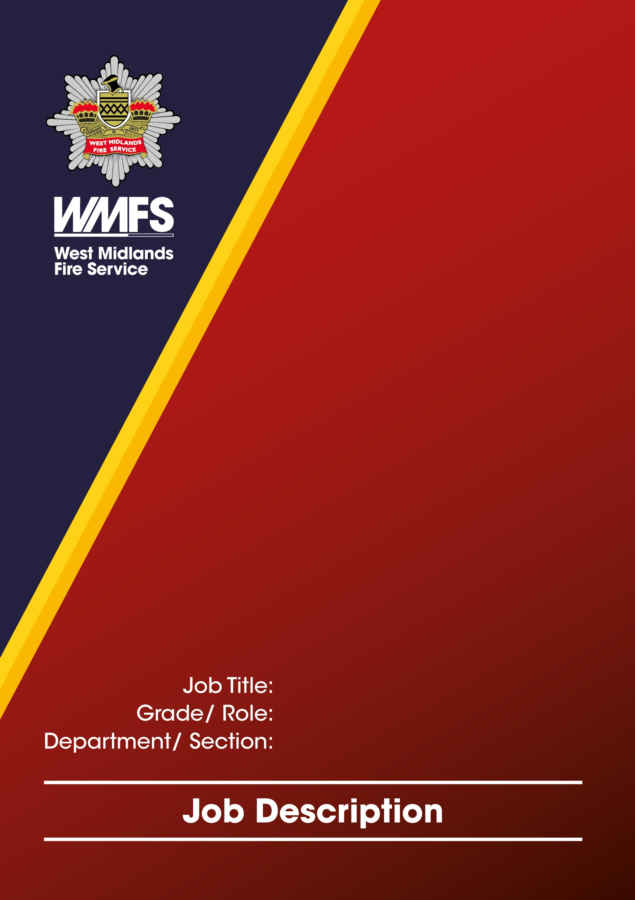
Auto Electrician
Technical 1C
Transport Engineering Workshops (TEW) / Corporate Services
JOB DESCRIPTION

Job Title: | Auto Electrician
Grade / Role: | Technical 1C
Reports to: | Principal Workshop Technician
Section: | Corporate Services
Department: | Transport Engineering Workshops (TEW)

Job Summary

Under the direction of TEW Principal Workshop Technician carry out maintenance, diagnostics, and repairs on a range of vehicles and equipment electrical systems, ensuring all work is performed to WMFS, manufacturer and safety standards, contributing to efficient workshop operations minimising vehicle and equipment downtime.
To provide specialist knowledge in relation to emergency service electrical system and components.

Responsibilities and Duties

To undertake scheduled electrical routine maintenance, adhoc repairs and modifications to Brigade LGV, PCV and PCL vehicles and equipment and to external Brigade and company vehicles and equipment. Keeping said maintenance to Ministry standards and in line with manufactures standards and specifications.

Utilising various items of diagnostic equipment and processes to ascertain the serviceability of a vehicle or auxiliary equipment.

Read and interpret wiring diagrams, technical drawings, and service manuals.

Apply logical, progressive and appropriate diagnostic techniques to determine reported malfunctions in vehicles, components or associated electrical systems. To make recommendations on any identified system improvements or modification designed to enhance electrical safety and reliability.

Decommission emergency electrical systems on disposal vehicles.

To complete and process all documentation in relation to the servicing and repairs of vehicles and equipment, required to comply with legislation as prescribed by the Principal Workshop Technician using Fleet Management systems (my tech app).

Through an ongoing training program, we will be able to deliver a high level of technical knowledge and advice to maintain the high standards required to support compliance with legislation and statutory duties and to facilitate the delivery of effective services.

Be able to understand and assist in your contribution towards the West Midlands Fire Service objectives, by supporting the team to deliver the functions and objectives of the Action Plan.

Carry out duties in a proactive and responsible way to reduce the downtime of vehicles/equipment to help to reduce the impact of your work on the environment.

Help to support through negotiation, and team meetings any changes that you feel need to be made to improve standards procedures or processes

To mentor, instruct, train and guide TEW Workshop Technicians and Apprentice Workshop Technicians on a one-to-one basis

To undertake repairs and maintenance of vehicles and equipment outside of the prescribed trade but within the general capabilities of a craftsperson.

Liaise with other departments both internally and externally to progress the work through the workshop in the timeliest and most cost-effective manner, ensuring that work standard remains at the pinnacle of expectations.

Work alongside TEW stores department in the procurement of various parts and/ or tools when maintaining / repairing vehicles and equipment.

Carry out ongoing training where required to meet greener solutions to protect the environment, (EV or hybrid vehicles).

Ensure all work areas, tools and workshop equipment are kept clean, safe, and serviceable both on site and off site complying with safe working practices alongside the Health and Safety at Works Act 1974.

Uphold and actively promote the Equality and Diversity policies of the West Midlands Fire Service.

Carry out other duties commensurate with the grade of post as required.

Special Conditions (include any special conditions, for example shift patterns, hours of work, working outdoors etc.)

Core shift 08:00 – 16:00

Attend brigade sites as required to provide a mobile repair service.
Overtime as required

Role related knowledge, skills and experience

Essential

- Repair and maintenance of LGV, PCV DVSA legislation

- Repair and overhaul of major components both mechanical and electrical

- Use of Workshop equipment electrical and mechanical

- Health and safety regulations within the working environment

- Willingness to undertake training courses away from home

- Dependable character able to work on own or with others

- Accuracy and high level of quality

- Flexible approach to working duties

- Practical and mechanically minded

- High level of dexterity

- Able to interpret drawings and design/development product ideas

- Ability to communicate effectively

- Able to undertake physically strenuous tasks

Preferred

- Experience in the use of fleet management software applications

- Experience in emergency services workshop

Qualifications

Essential

- Trade qualifications City & Guilds electrical certificate in motor vehicle technology or NVQ level 3 or equivalent.

- Good standard of education. Minimum 3 GCSE or equivalent.

- UK LGV driving license

Preferred

- Driving License with C1 entitlement.

Level of DBS required (eg: Basic, Standard, Enhanced, Enhanced with Barred List)

Basic

